Quantitative Data Analysis
Questions on SES and demographic were only asked in the pre-training survey because they could not change (ethnic background, caregivers’ educational level) or were not expected to change (gender, students’ occupation) in the one or two weeks between surveys. Other than this, the quantitative survey data was compared between the pre-training and post-training datasets: the mean and range of scores were compared from the AI literacy section and mode and range were compared for the agreement scales.

Qualitative Analysis
For the research team to compare students’ interview data, a deductive approach to thematic analysis was followed due to time constraints (Clarke and Braun, 2017). Codes were defined according to previous literature on the topic (Fife and Gossner, 2024) regarding AI policies and admission policies in universities, AI literacy, and socioeconomic barriers to AI studies as defined in the literature review of this report. Some additional codes were added based on responses in pilot interviews conducted with each member of the research team. This allows for the testing of previous claims in a newly emerging social phenomenon and to expand the knowledge on this topic according to new themes emerging from the empirical data (Fife and Gossner, 2024). Researchers conducted the analysis in a shared codebook (Appendix ) document where codes were generated and reviewed both asynchronously and in dedicated meetings.
It is important to note that the AI training delivered by the JGI focused on AI literacy rather than other real or perceived barriers to AI doctoral studies as identified in the literature review (above). The partial lack of alignment between the literature review and the AI training had an impact on data collection and analysis, as some previously identified codes were not addressed as part of the post-training interviews (e.g., gender inequality in AI studies and confidentiality concerns). Additionally, some aspects of the literature review could not be addressed because of the sample of undergraduate students; for instance, admission policies related to doctoral studies in AI could not be investigated. Further studies could be developed to provide a more in-depth understanding of the different, intersecting dimensions that may impact doctoral studies in AI.
The free-text responses from the surveys were analysed by the interviewers using abductive content analysis (based on iterative steps described by Erlingsson and Brysiewicz, 2017). The predefined codes generated for thematic analysis of the interviews were used in the deductive process, and codes were derived from the data to enable a frequency analysis which sufficiently described the dataset. The content analysis process was similar to the steps followed for the thematic analysis of the interview transcripts. Due to the brevity of most free-text responses, deep immersion and understanding of the data would have been difficult to achieve, so content analysis enabled meaning to be efficiently categorised across the dataset (Humble and Mozelius, 2022).
These qualitative approaches provided descriptive insights into how the training programme may have altered attendees’ attitudes towards AI and further study. These complemented the quantitative survey data to understand a broader range of rationale for students’ responses, rather than provided explanations for the impacts of the training on individuals.
The following sections will discuss the generated findings.

Quantitative Results

Survey
Before conducting the paired analyses, the initial dataset of 14 matched pre- and post-training surveys was cleaned to ensure data integrity. One participant was excluded for completing both surveys consecutively (two minutes apart), indicating they did not attend the training between test administrations. For a participant with multiple post-survey submissions, only the first complete submission was retained to prevent practice effects from skewing the data. This resulted in a final matched sample of n=13 for the paired analyses.
To evaluate the impact of the training on AI knowledge (H2 and H4), two complementary scoring methods were applied to the 10-item AI-LITS test:
- Raw Percentage: A standard calculation of total correct answers out of 10, providing a straightforward measure of overall knowledge acquisition.
- Item Response Theory (IRT) Ability Score (θ): To provide a more robust evaluation of underlying conceptual mastery, responses were also scored using a 3-Parameter Logistic (3PL) IRT model. Using the fixed item parameters validated by Hornberger et al. (2025), this model estimates a "true ability" score (θ) by weighting each question based on its specific difficulty, how sharply it discriminates between ability levels, and adjusting for a 25% guessing probability on multiple-choice items. Because the IRT model weights hard questions differently than easy questions, it provides a stricter evaluation than the raw percentages.
For clarity and ease of interpretation we will compare both in this analysis. Furthermore, data from the interviews are provided alongside the quantitative analyses to provide descriptive context for the results. Results of the content analysis are presented in the following section as they reveal a greater variety of factors which do not all directly relate to the hypotheses here.
H1: Does the AI training programme increase attendees’ interest in AI study? To evaluate shifts in student interest regarding future AI studies, pre- and post-training survey responses were analyzed using the non-parametric Wilcoxon Signed-Rank Test, which is appropriate for ordinal Likert-scale data. Two proxy measures were evaluated: student confidence in being offered a PhD place, and direct willingness to apply for an AI PhD.
When asked to rate their agreement with the statement, "I think I would be offered a place to study a PhD in AI if I applied" (1 = Strongly Disagree to 5 = Strongly Agree), the median score remained static at 2.0 (Disagree) before and after training. The mean score shifted positively from 2.15 to 2.54, which a Wilcoxon test indicated is a weak trend approaching, but not reaching, statistical significance (W = 18.0, p = 0.094). A similar pattern emerged regarding the direct question, "Would you consider applying for a PhD in AI?" (0 = No, 1 = Maybe, 2 = Yes). The median response remained firmly at 1.0 (Maybe). While the mean score rose slightly from 0.77 to 0.92, this change was not statistically significant (W = 10.0, p = 0.375).
Collectively, the quantitative data suggests that while the training successfully increased objective AI literacy (as seen in H2), a short technical intervention alone is insufficient to significantly alter deeply held career intentions or overcome confidence barriers regarding PhD admissions.
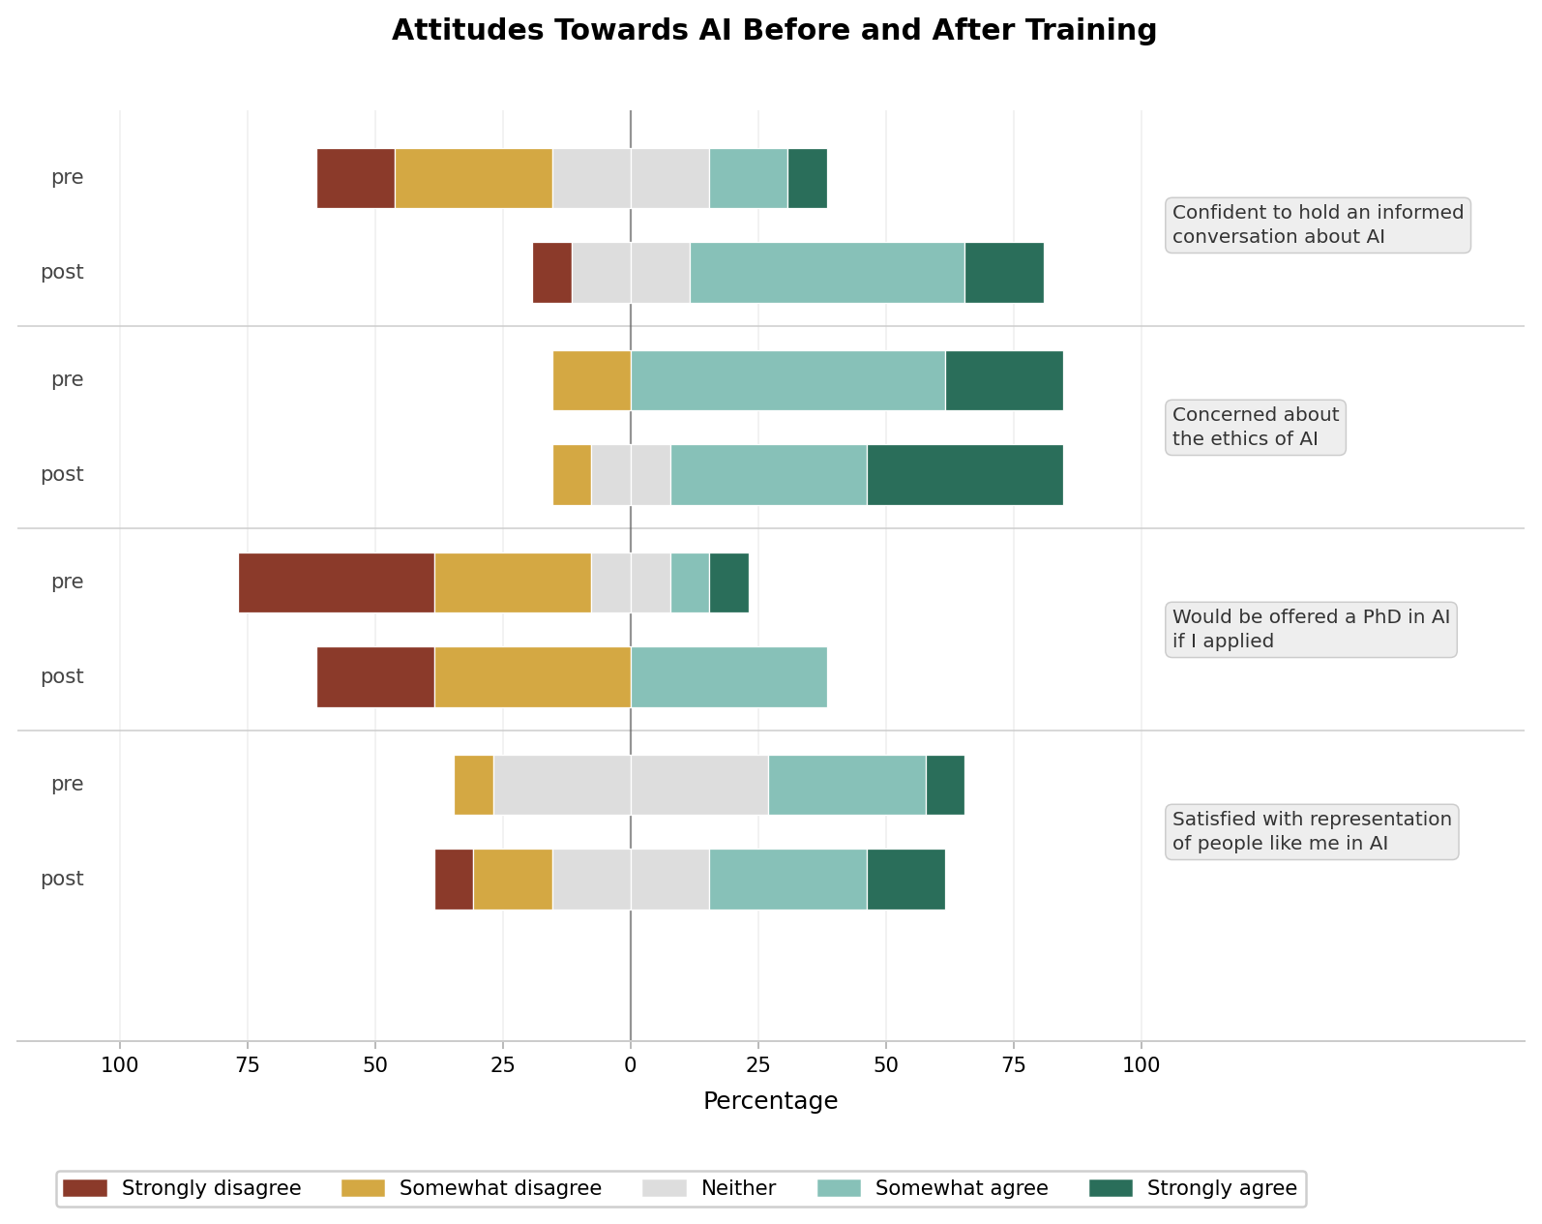
Figure 7: Pre- and post-training shifts in AI attitudes (n=13). Diverging stacked bar chart showing a marked increase in confidence to discuss AI, alongside positive directional trends in perceived PhD eligibility and representation.
These trends are further explored during interviews with participants, who outline explanations related to their current field of study, the limitations and opportunities of the job market, and personal career decisions.
For some interviewed participants, engaging with AI was important as a user of these systems was more important rather than studying AI. The application of AI was not clear to them in their fields, e.g., social sciences and marketing. This is also connected to the skills they have obtained in this pathway, which are less hard-science oriented. For these participants, the concern was to use AI ethically, understand its many applications in their work, and haveing the knowledge to make full and optimal use of it.
“I don't know if taking a career, but learning more about it, getting more into more courses like this one”
While future careers may not be explicitly linked to barriers to doctoral AI studies, all participants in the present research project talked about their career expectations as part of their chosen degree and potential post-graduate studies. The ambiguity about future careers in the future was one of the factors influencing the decision to take pursue AI postgraduate studies. Concerns varied between the competitiveness of the field, uncertainty regarding the needed expertise within it, and the lack of knowledge about understanding of how it connects to areas such as the social sciences. For participants with an engineering background, the concern was about the limited number of job opportunities in AI in comparison to a more general engineering specification:
“I chose [this degree] because...I thought it's very broad here in England and I can go into any industry that I want. They will always need a mechanical engineer for something”
Participants clearly addressed that the application of AI is not well-known in most fields. More clarity about careers in AI was a type of support they perceived as needed to make this decision.
One interviewed participant shed light on more competitiveness in the job markets for migrants, especially in highly paid jobs.
“There's always the risk of something being true right now, but then completely changing in a year's time because of the nature of the field where everything is changing rapidly”
However, for some participants, being exposed to technical skills in AI and to some concepts was important to further discuss exposure to AI technical skills and concepts was important for discussing future careers. For others, it was eye-opening to the potential within a pathway of their interest.
“I feel like it would depend on my future career choices, because right now I'm in between two options”.
“Yeah, I'm interested in financial, the financial side of marketing. So that's pretty much related to AI in terms of data analysis, so if I were to choose that, I think I would get more into AI”
“So I felt like I didn't know enough about this whereas I should, especially because I want to pursue this in the postgraduate level […] I think there was a lot of space in robotics to incorporate artificial Intelligence and make autonomous robotic systems”
An important theme that emerged was the willingness to engage with AI in fear of future career competitiveness. Interviewed participants were cautious about the need for skills in AI for their future employment. Despite not knowing what the job market would look like, they believe that using AI systems is now essential for the future. This raises the question of whetherould the absence of this scenario would impact their willingness to enhance their knowledge and skills related to AI?
“Because it would be like a major part of my future, like where I would be in my career in the future”
“AI is very, very important nowadays and it is going to get more and more important”
It is also important to note that one participant implied a perception of an AI career in the UK being mostly open to UK population only:
“And actually, one of the guys [delivering the training] was [from abroad], so we had a chat in [their home language] as well...I'm not from England, so that's really good to know that anyone can get into it”
The above quote may imply a degree of intersectionality between race/ethnicity/migration and chosen career path, hence higher education studies. However, the small number of participants and the narrow focus of the study (due to time constraints) mean that more studies should be conducted to further understand the above intersections.

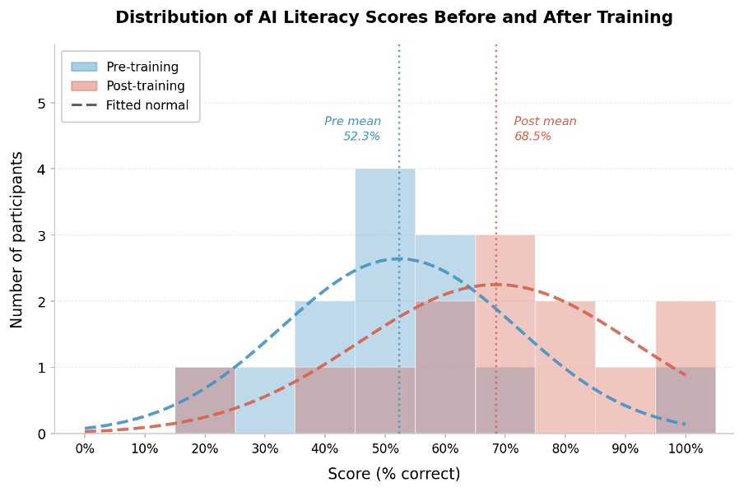Figure 8: Raw AI literacy questionnaire scores before and after training. This histogram illustrates a significant 16.2% increase in the mean score (from 52.3% to 68.5%) for the 13 participants, indicating clear knowledge acquisition.

H2: Does the AI training programme increase attendees’ AI literacy?
Analysis of the 13 matched pairs revealed a strong positive trend following the training intervention. When evaluating the simple raw percentage scores, participants improved by an average of 16.2 percentage points—shifting from a baseline mean of 52.3% to a post-training mean of 68.5% (see Figure 4). A paired-samples t-test indicated that this raw improvement was statistically significant (p = 0.024), confirming the training successfully imparted measurable knowledge of core AI concepts.
When evaluating the IRT model (θ), the mean true ability estimate demonstrated a substantial positive shift, increasing from 0.094 to 0.586, which represents nearly half a standard deviation (see Figure 5). Because the 3PL model is highly sensitive to individual response patterns, it introduces higher variance than raw scoring, rendering the analysis statistically underpowered at n=13. Nevertheless, the strong directional alignment between the significant raw percentage increase and the positive θ shift supports the overall efficacy of the intervention.

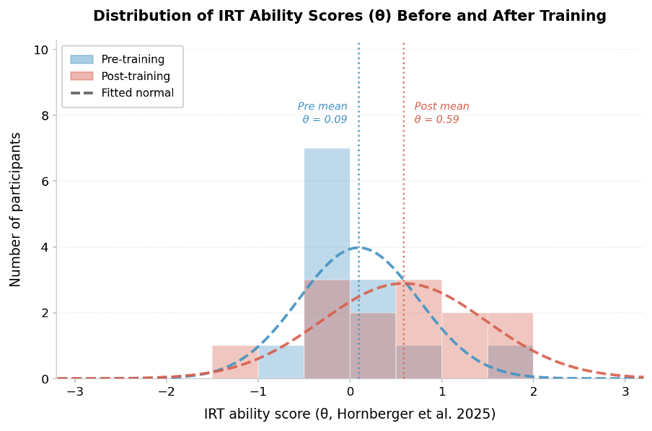
Figure 9: IRT ability scores from the AI literacy questionnaire. Based on the 3PL IRT model, this histogram shows the shift in mean ability from 0.09 to 0.59 (n=13), representing growth of nearly half a standard deviation.
The interviewed sample emphasised the importance of technical skills as a factor in their evaluation of what encourages them or discourages them from engaging with AI studies.
Being knowledgeable of the general concepts, such as LLMs or neural networks in addition to coding skills, had a positive influence on participants’ attitudes towards engaging more with AI as users in areas that might be related to their studies.

H3: Is there any difference of interest in AI study based on SES?
The self-selecting nature of the training attendees revealed a severe demographic skew: 12 of the 13 matched participants fell into the Higher SES category, leaving only 1 participant in the Lower SES category. Due to this extreme imbalance, formal comparative hypothesis testing is impossible.
While statistical conclusions cannot be drawn from a sample size of one, the fact that only a single first-generation student completed the AI training pipeline highlights a critical systemic issue regarding accessibility and early-stage engagement in AI education. As a key lesson learned, future research should employ a purposive sampling strategy to actively recruit students from diverse socioeconomic backgrounds, which would yield much stronger and more robust findings on this front.

Group | n | Mean pre | Mean post | Mean change
STEM | 6 | 56.7% | 78.3% | +21.7pp
Non-STEM | 7 | 48.6% | 60.0% | +11.4pp
All | 13 | 52.3% | 68.5% | +16.2pp
Table 4: Pre- and post-training AI literacy score changes by subject area. This table displays the mean raw percentage scores and the average percentage point (pp) change for STEM and Non-STEM cohorts. The STEM cohort started with a higher baseline score and gained more improvement from the training.
The conducted interviews were able to discuss only the aspect of accessibility to capacity building opportunities in terms of SES-related factors and in a specific group of undergraduate students studying at the University of Bristol.
In the context of reflecting on the training the participants attended, they highlighted some aspects of accessibility to these opportunities. They believe that being part of the university allowed them to access a few trainings that have better introduced them to AI. While one training of the training sessions some of the students attended was more aboutfocused on AI ethics the ethics of using AI, the “Getting Started in AI” training was more technical. Interviewed participants value this exposure as they identify its impact on their awareness of potential applications of AI within their current studies and the future. In general, the interviewed participants appreciated the technical development the training offered. Even though that was not a breaking factor in their decision to pursue AI studies, it offered awareness of the field and what it might include for students who were considering a related postgraduate degree.
“I also took the course to kind of help me decide whether I'd like to pursue a Masters of Science in AI rather than Masters of Science and Engineering, which was my original path”.
indicated that being invited through email and posters, promotion of a free training, and being in a friendly environment encourages people to engage with AI more. This will allow people to be better informed and technically equipped, increasing confidence in pursuing a degree in AI.
Interestingly, the reflection on accessibility did not expand to minorities and disadvantaged people. This can be contextualised within the biases of the sample this study engaged with.
H4: Do STEM students show higher AI literacy than non-STEM students before and after the training?
To understand if prior academic background influenced AI literacy, the matched sample (n=13) was divided into STEM (n=6) and Non-STEM (n=7) cohorts based on their enrolled degree programs.
Prior to the training, STEM students exhibited a higher baseline AI literacy than their Non-STEM peers. The STEM cohort achieved a mean raw score of 56.7% (mean θ = 0.251), compared to the Non-STEM cohort's mean raw score of 48.6% (mean θ = -0.041). This confirms that STEM students enter with a slight measurable advantage in AI literacy.
While both groups benefitted from the intervention, STEM students experienced substantially higher growth. As visualized in Figure 3, the STEM cohort's raw scores surged by +21.7 percentage points to a final mean of 78.3% (θ increase of +0.816). In contrast, the Non-STEM cohort saw a more modest increase of +11.4 percentage points, finishing with a mean of 60.0% (θ increase of +0.215). Due to the small sub-sample sizes, within-group paired t-tests did not reach statistical significance. However, the descriptive data clearly indicates that while the training successfully elevates literacy across all academic backgrounds, it appears to act as a stronger catalyst for students already embedded in STEM disciplines, effectively widening the literacy gap between the two groups rather than closing it.
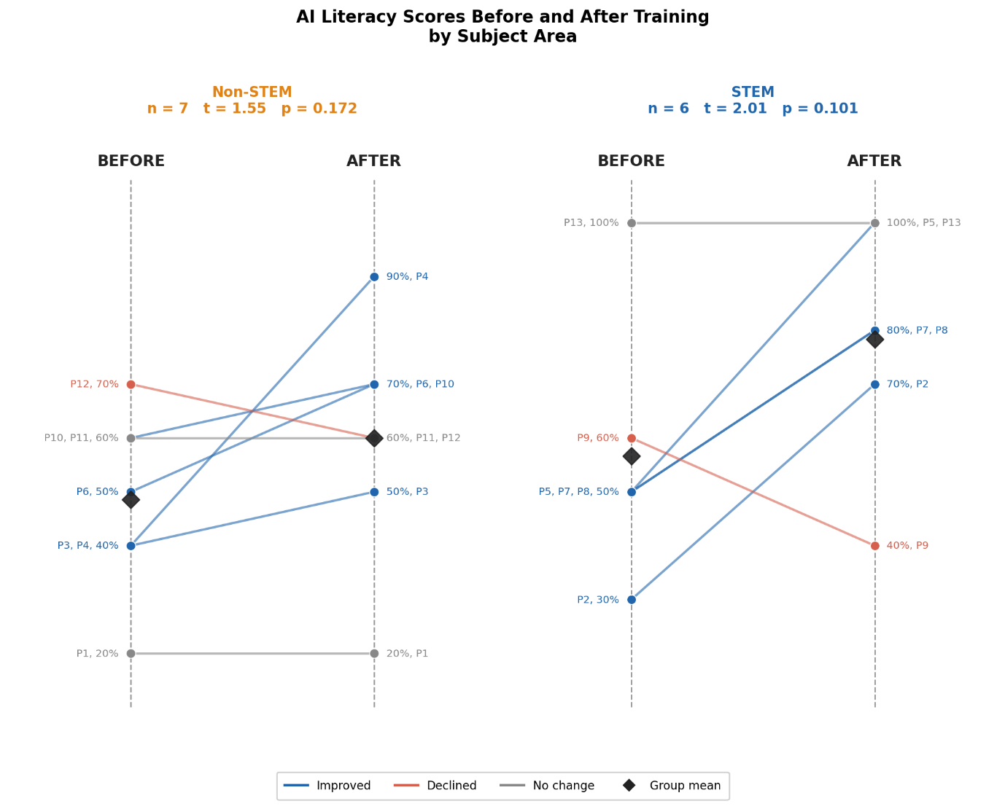
Figure 10: Individual and group shifts in AI literacy by subject area. This slope chart compares the pre- and post-training scores for Non-STEM (n=,7 left) and STEM (n=7, right) students. The STEM group began with a higher mean baseline (56.7%) than the Non-STEM group (48.6%). The blue lines indicate improvement, showing that while both groups gained knowledge, the STEM cohort experienced a more pronounced average increase.
The qualitative data explains these patterns in more detail,s expanding on the interrelated themes of technical skills, training evaluation, and attitude towards AI. In addition, havingHaving priorevious coding skills and experience helped students them feel more confident in expanding their knowledge about AI and considering further studies in it. Some participants expressed being feeling less inhibited by the idea after taking the hands-on session that introduced them to some practical aspects of coding. Also, they emphasised the importance of understanding the mechanism behind AI and how it works, which helped them make better connections between it and the work that they do. Additionally, participants in the training particularly appreciated having AI substreams broken down for an easier learning experience.
“So the way I use LLMs was also affected in terms of when realising and understanding how something works. You know how to better use it based on its underlying mechanism”
The change in perspective included the knowledge and skills needed to study AI. Participants declared that they were under the impression of a deep knowledge of maths and coding, which inhibited their engagement with AI. This perception changed following the training.
“I come from an engineering background, so I've done some Python, and I know like some coding. If I read some code, I would probably understand what it's doing”
On the other hand, having little or no skills in coding and little knowledge about AI was a factorcoding skills and limited knowledge of AI were factors that made participants less willing to further explore the training, let alone develop further interest in postgraduate studies in related topics.
“Maybe it's because of like I don't have that technical background of it. So like I got the base of it, but still like I'm not- probably I won’t go for an AI postgrad”
It is important to consider that these skills and knowledge are developed over the years through previous decisions in schools and undergraduate programmes and enhanced by personal interest and environmental influence.
“Back in my high school, like uh, it's quite similar to the A-levels in the UK. So I took like Politics, Geography, History and Economics. I never got any chance to like study like Python and like stuff like that because it seems so complicated to like a person from social science major to study”

Free-Text Survey Responses
The content analysis of the free-text responses in the surveys revealed the frequency of different topics mentioned by the participants pre- and post-training, according to the following prompts:
- Please list up to three things that interest you in studying AI.
- Please list up to three things that interest you in undertaking a PhD.
- Please write up to 100 words about [what has motivated you to take / your experience of taking] part in the AI training offered by the Jean Golding Institute.
The responses provide an insight into factors which contribute to participants’ interest in studying AI (supplementing H1 further) and their motivations in AI study which may be useful in overcoming barriers (addressing motivational aspects of RQ1).
The frequency of prominent topics mentioned in response to these questions in the pre- and post- training surveys are displayed in Figures 11, 12 and 13. The results are presented in order of the highest to lowest percentage of responses to the pre-training survey containing each topic. It is worth noting that the titles used to represent the different ideas that interest students in studying AI, undertaking a PhD and taking part in the training programme are named “topics” here to distinguish them from the “codes” derived from the interviews.

Interest in Studying AI
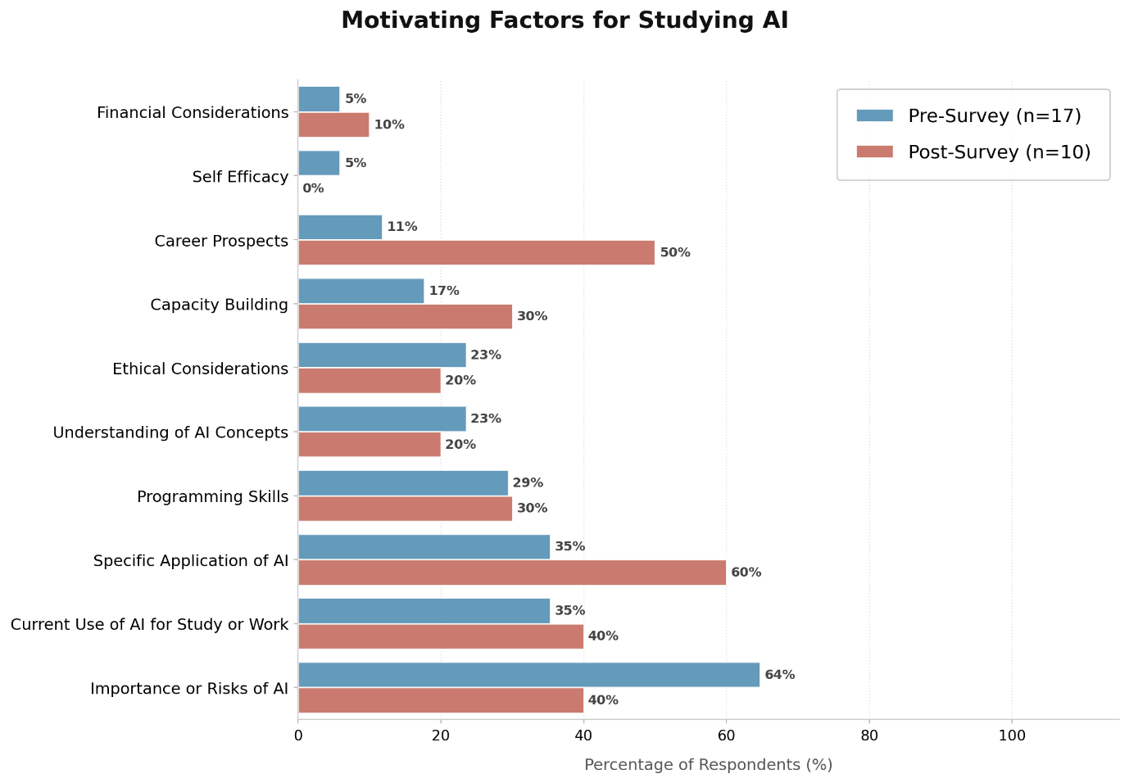
All the topics featured in responses from the pre- and post-training survey question on participants’ interest in studying AI are listed below in Figure 11.
Figure 11: Bar chart displaying the percentage of responses which feature the various factors that interest participants in studying AI.
The “Importance or Risks of AI” related to respondents’ concern that learning AI is necessary for preparing for future careers or otherwise “futureproofing” as well as the inverse: that not understanding AI risks negative impacts on one’s aptitude for future careers. This was the most frequently stated motivator for participants before they underwent training (included in 64% of responses), though the proportion of respondents mentioning the “Importance or Risks of AI” in the post-training surveys reduced to 40%.
Participants expressed the belief that AI study would further their ability to use it in study or work in the near future (“Current Use of AI for Study or Work”) in 35% of responses prior to the training, rising to 40% of responses afterwards. They also frequently described “Specific Applications of AI”, especially in data science, as motivating their interest to study AI. Prior to the training, 35% of respondents mentioned this factor while after the training it featured in 60% of responses.
“Programming” was also commonly mentioned by respondents - 29% pre-training and, similarly, 30% post-training. Both before and after the training, this mostly related to respondents’ expressions of interest in improving coding skills or understanding how to create AI tools. These were often connected with needing to learn to programme AI in order to use it better, and so “Current Use of AI for Study or Work” and “Programming” were often paired in responses.
“Ethical Considerations” and “Understanding of AI Concepts” were both cited in 23% of responses prior to the training and featured in 20% of responses afterwards. Before the training, participants who were concerned with the ethical – including “societal” - impacts of using AI tools often expressed these as the focus of their motivation for studying AI. They mostly provided explicit recognition of a need to understand the facets of how AI tools operate in order to understand these ethical impacts comprehensively. There were also responses where the importance of understanding how AI works was related more closely with the development of AI or applying it in specific areas; it was not always described in relation to ethical concerns.
Fewer respondents referred to a need for “Capacity Building” (17%), learning AI to improve “Career Prospects” (11%), wanting to improve confidence in using AI either now or in future (“Self Efficacy”, 5%), and that studying AI may relate to finances in some way (“Financial Considerations”, also 5%) prior to the training. Notably, “Capacity Building” and “Career Prospects” rose significantly after respondents’ attendance to 30% and 50% respectively, further suggesting that as a result of the training, their interest in AI became more orientated towards skills acquisition and preparing for future careers than concerns around its use, which was more dominant in the pre-training surveys.

Interest in Studying a PhD
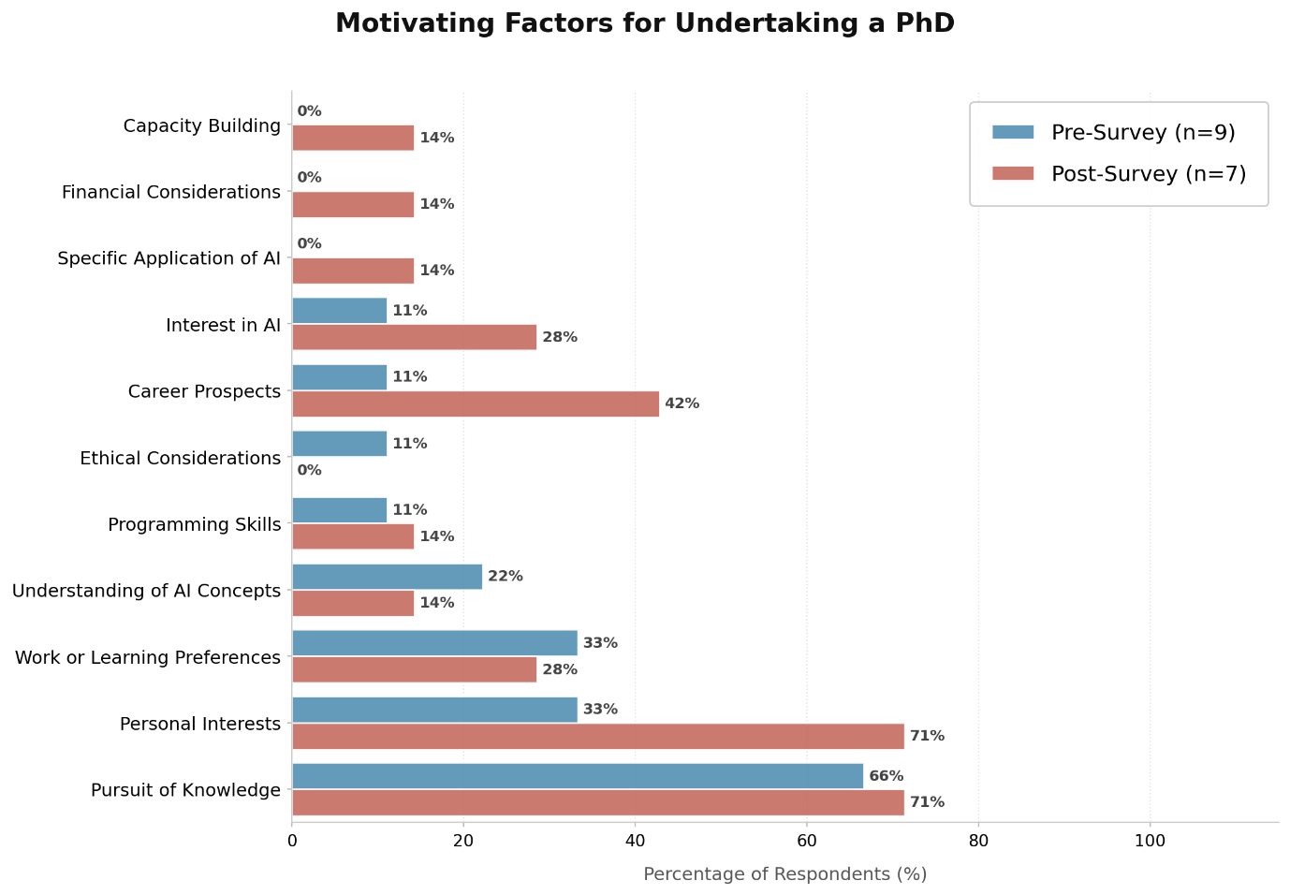
The topics arising from respondents’ interest in studying a PhD before and after attending “Getting Started in AI” are summarised in Figure 12 below.
Figure 12: Bar chart displaying topics related to participants’ interest in undertaking a PhD by the percentage of responses in which they featured.
Motivational factors for undertaking a PhD were more closely aligned with knowledge acquisition, personal interests and workstyle preferences than expressions of interest on what encourages them to study AI.
The “Pursuit of Knowledge” was mentioned frequently both before and after the training sessions (mentioned by six respondents, 66%, before and six, 71%, after the training). This topic was characterised by respondents’ interest in developing knowledge, which was distinct from wanting to acquire functional knowledge that would improve their ability to use AI (which would relate to Using AI for Study or Work). Participants described wishing to study a PhD in order to be able to engage in prolonged, deep investigations of interesting topics, mostly without mentioning a specific field they wished to pursue. This was closely connected in the post-training responses with the idea that pursuing knowledge in this way would enable them to follow personal interests (hence they both featured in 71% of post-training responses), though only half the participants mentioning the “Pursuit of Knowledge” linked this explicitly with their “Personal Interests”.
Respondents communicated an awareness that PhD study would enable them to work on long-term projects at a very high level, at rates of 33% pre-training and 28% post-training, which related to them displaying “Work or Learning Preferences”.
Two students (22%) mentioned wanting to understand AI through studying a PhD before the training, one of which (11% for “Programming”) described wanting to develop programming skills as part of this and having specified AI as a topic of interest (11% for “Interest in AI”). These topics were maintained by one student following the training as well (14% for both “Understanding of AI Concepts” and “Programming”).
One participant (11%) related PhD study to “Career Prospects” before the training but three (42%) mentioned “Career Prospects” in their post-training response. This distinction was marked by descriptions that implied a recognition of undertaking a PhD as an alternative to entering other work after graduating from their course. Unlike perspectives on studying AI, “Career Prospects” were considered more in terms of what students desired to pursue rather than what preparations they must make for future work.

Attendance of the Training Sessions
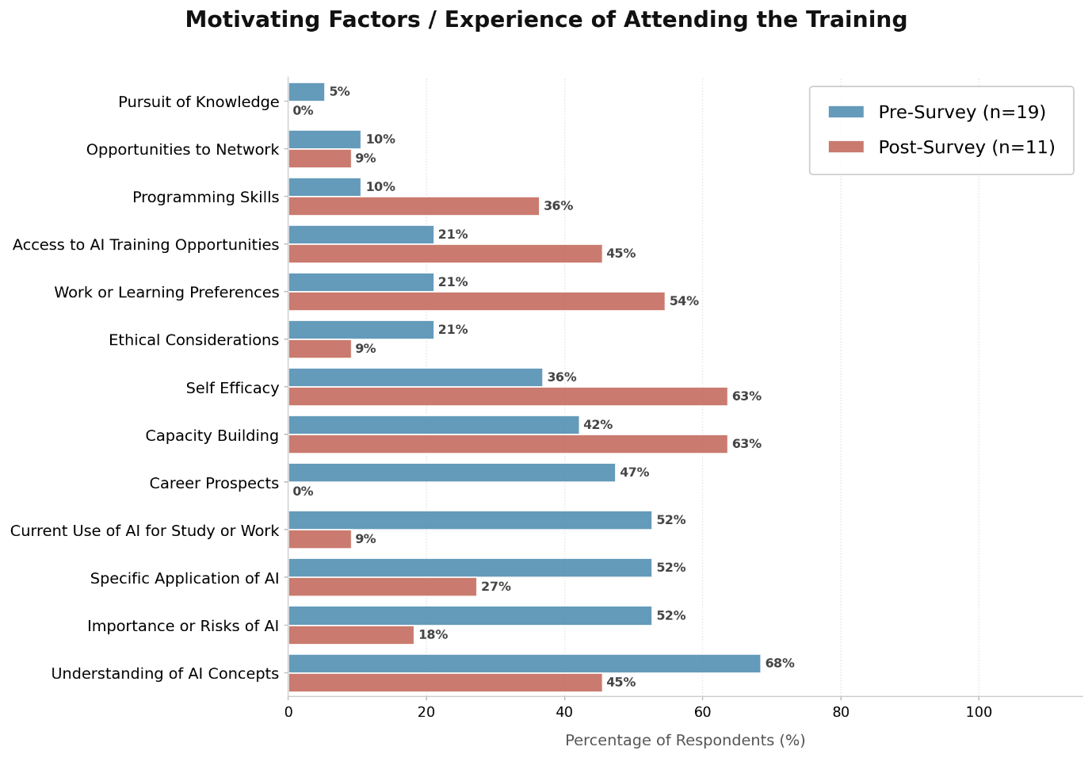
Figure 13 below shows the frequency of various topics featured in responses to what participants anticipated before the training and in their reflections on the training.
Figure 13: Bar chart displaying the frequency of topics in responses to motivations for (pre-) and experiences of (post-) taking part in the Getting Started in AI training.
The initial motivations for participating in the training were primarily driven by desires to develop their technical understanding and use of AI, as well as personal growth. “Understanding of AI Concepts” (68%), alongside “Importance or Risks of AI” and “Specific Applications of AI” were the most commonly mentioned motivators for undertaking the training. They primarily relate to the sense communicated by respondents that AI is necessary for “future-proofing” or preparing for future careers. By reflecting on their potential future career paths, students referred to their respective fields in which they see increased AI use. This is also supported by the “Career Prospects” theme that appeared only in the pre-survey responses (47%), suggesting that despite the personal motivations, the training functioned as a bridge to support students in developing the technical skills necessary for their future success.
This effect can be observed in the reported increase in “Self-Efficacy” between the (pre-) and (post-) training surveys, from 36% to 63%. Here, students reflected on the training as a starting point for increasing their belief in their skills, supporting their AI learning journey, rather than as a final destination. “Capacity Building” was frequently mentioned in the post-training reflections, with students emphasising the training's role in providing valuable learning opportunities and overall accessibility to help them navigate the AI field. There was an increase in the proportion of respondents referred to the accessibility of the training as “Access to AI Training Opportunities” (including the value of incentives in their decision to attend): 21% before and 45% after. Moreover, many respondents communicated their enjoyment or appreciation of the applied, “practical” learning of AI concepts which were not as commonly considered before the sessions. This is reflected in the rise of “Work or Learning Preferences” from 21% to 54%.
Other than this, “Ethical Considerations” were more common in the pre-training surveys than post (in 21% versus 9% of responses) but other factors saw an increase in the post-training survey. “Programming Skills” and “Opportunities to Network” both saw mentions by 10% of respondents before the sessions with “Programming” increasing to 36% of responses post-training (which is as expected given the technical focus of the syllabus), while references to networking or learning with others reduced to 9% post-training. One participant (5%) expressed being motivated by “Knowledge Pursuit”: “I would love the opportunity to (learn about AI capabilities and ethics) to boost my knowledge” but no responses mentioned “Knowledge Pursuit” after the training in line with the definition provided in Section <Interest in PhD Study>.

Limitations
Content analysis is useful for providing an overview of the topics which have been described by participants. It does not reflect that the level of detail was inconsistent across responses, which in turn would reflect that there were large differences observed in the level of consideration participants had given to what interests them in studying AI, undertaking a PhD and attending the training. Furthermore, some responses had vague/multiple meanings, such as the “currency” of AI as a factor for its study. In reviewing the topics, different members of the research team discussed whether this may mean that AI is significant and relevant at the moment, or whether possessing AI skills can be considered as currency in the evolving job market which increasingly focuses on the use and development of AI. Encouraging more descriptive responses for all free-text questions may have reduced the need for interpretation, building a more direct understanding of participants’ perspectives.
Overall, there was a greater spread of topics mentioned after attendance of the training: “Specific Applications of AI”, “Financial Considerations” and “Capacity Building” were additional topics, and some responses also included elements of what they wished for in studying a PhD.
The interview participants may have also completed the pre- and post-training surveys, so the two qualitative analyses are not independent of one another.

Interviews

Findings:
In this section, the research explores the factors that may influence participants’ decisions in pursuing a postgraduate degree. Importantly, since the sample was composed of undergraduate students, they elaborated more on factors that influenced their decisions to pursue their current degrees generally. With the acknowledgement of the specificity of AI studies, the research finds value in understanding general trends as well:
- AI Literacy Barriers and Enablers:
1.1. Technical skills acquisition
Technical skills were the most mentioned factor in participants' evaluation of what encourages them or discourages them from engaging with AI studies.
Being knowledgeable of the general concepts such as LLMs or neural networks had a positive influence on participants’ attitudes towards engaging more with AI as users in areas that might be related to their studies.
In addition, having previous coding skills and experience helped them feel more confident in expanding their knowledge about AI and considering further studies in it. Some participants expressed being less inhibited by the idea after taking the hands-on session that introduced them to some practical aspects of coding. Also, they emphasised the importance of understanding the mechanism behind AI and how it works, which helped them make better connections between it and the work that they do. Additionally, participants in the training particularly appreciated having AI substreams broken down for an easier learning experience.
“So the way I use LLMs was also affected in terms of when realising and understanding how something works. You know how to better use it based on its underlying mechanism”
The change in perspective included the knowledge and skills needed to study AI. Participants declared that they were under the impression of a deep knowledge of maths and coding, which inhibited their engagement with AI. This perception changed following the training.
“I come from an engineering background, so I've done some Python, and I know like some coding. If I read some code, I would probably understand what it's doing”
On the other hand, having little or no skills in coding and little knowledge about AI was a factor that made participants less willing to further explore the training, let alone develop further interest in postgraduate studies in related topics.
“Maybe it's because of like I don't have that technical background of it. So like I got the base of it, but still like I'm not- probably I won’t go for an AI postgrad”
It is important to consider that these skills and knowledge are developed over the years through previous decisions in schools and undergraduate programmes and enhanced by personal interest and environmental influence.
“Back in my high school, like uh, it's quite similar to the A-levels in the UK. So I took like Politics, Geography, History and Economics. I never got any chance to like study like Python and like stuff like that because it seems so complicated to like a person from social science major to study”
The appreciation for developing AI skills found in the free-text responses may also support that participants perceive skills and knowledge gaps relating to Long and Magerko’s (2020) AI literacy competencies. Some examples from the survey responses include “coding” relating to 17) Programmability, “ethics” clearly reflecting competency 16) Ethics, or a more complex example being “understanding... if (AI’s) objectivity ultimately depends on human design and development” comprising elements of 8) Decision-Making, 10) Human Role in AI, 12) Learning From Data, 13) Critically Interpreting Data and 16) Ethics.

1.2. Capacity building and training accessibility:
In the context of reflecting on the training the participants attended, they highlighted some aspects of accessibility to these opportunities. They believe that being part of the university allowed them to access a few trainings now that have better introduced them to AI. While one training some attended was more about the ethics of using AI, the “Getting Started in AI” training was more technical. Interviewed participants value this exposure as they identify its impact on their awareness of potential applications of AI within their current studies and the future. In general, the interviewed participants appreciated the technical development the training offered. Even though that was not a breaking factor in their decision to pursue AI studies, it offered awareness of the field and what it might include for students who were considering a related postgraduate degree.
“I also took the course to kind of help me decide whether I'd like to pursue a Masters of Science in AI rather than Masters of Science and Engineering, which was my original path”.
indicated that being invited through email and posters, promotion of a free training, and being in a friendly environment encourages people to engage with AI more. This will allow people to be better informed and technically equipped, increasing confidence in pursuing a degree in AI.
The apparent increase in self-efficacy in 36% of pre-training survey and 63% of post-training survey responses for the third free-text question relates to findings from previous literature in Section 3.1.3 (Cowit and Fiesler, 2024). As such, the improved confidence in AI skills could aid participants in pursuing AI study if they so wished by reducing the likelihood of disengagement from learning AI earlier in the pipeline.
Interestingly, the reflection on accessibility did not expand to minorities and disadvantaged people. This can be contextualised within the biases of the sample this study engaged with.
- Career Enablers and Barriers:
2.1. Relevance to current pathway:
For some interviewed participants, engaging with AI was important as a user of the systems rather than studying AI. The application of AI was not clear to them in their fields, e.g., social sciences and marketing. This is also connected to the skills they have obtained in this pathway, which are less hard-science oriented. For these participants, the concern was to use AI ethically, understand its many applications in their work, and having the knowledge to make full and optimal use of it.
“I don't know if taking a career, but learning more about it, getting more into more courses like this one”
The relevance of studying AI to survey respondents’ immediate needs was a primary driver for attendance of the training sessions, as indicated by the significant percentage of citations (35% of pre-training respondents and 40% of post-training respondents). Respondents’ interest in AI revolving around using it for current study or future work is consistent with Yin and Goh’s (2024) observation that a key driver for learning AI due to its utility rather than pure technical interest in AI concepts.
- Future Career:
While future career may not be explicitly linked to barriers to doctoral AI studies, all participants in the present research project talked about their career expectations as part of their chosen degree and potential post-graduate studies. The ambiguity about careers in the future was one of the factors influencing the decision to take AI postgraduate studies. Concerns varied between the competitiveness of the field, uncertainty regarding the needed expertise within it, and the lack of knowledge about how it connects to areas such as the social sciences. For participants with an engineering background, the concern was about the limited number of job opportunities in AI in comparison to a more general engineering specification:
“I chose [this degree] because...I thought it's very broad here in England and I can go into any industry that I want. They will always need a mechanical engineer for something”
Participants clearly addressed that the application of AI is not well-known in most fields. More clarity about careers in AI was a type of support they perceived as needed to make this decision.
One interviewed participant shed light on more competitiveness in the job markets for migrants, especially in highly paid jobs.
“There's always the risk of something being true right now, but then completely changing in a year's time because of the nature of the field where everything is changing rapidly”
However, for some participants, being exposed to technical skills in AI and to some concepts was important to further discuss future careers. For others, it was eye-opening to the potential within a pathway of their interest.
“I feel like it would depend on my future career choices, because right now I'm in between two options”.
“Yeah, I'm interested in financial, the financial side of marketing. So that's pretty much related to AI in terms of data analysis, so if I were to choose that, I think I would get more into AI”
“So I felt like I didn't know enough about this whereas I should, especially because I want to pursue this in the postgraduate level […] I think there was a lot of space in robotics to incorporate artificial Intelligence and make autonomous robotic systems”
An important theme that emerged was the willingness to engage with AI in fear of future career competitiveness. Interviewed participants were cautious about the need for skills in AI for their future employment. Despite not knowing what the job market would look like, they believe that using AI systems is now essential for the future. This raises the question of would the absence of this scenario would impact their willingness to enhance their knowledge and skills related to AI?
“Because it would be like a major part of my future, like where I would be in my career in the future”
“AI is very, very important nowadays and it is going to get more and more important”
It is also important to note that one participant implied a perception of an AI career in the UK being mostly open to UK population only:
“And actually, one of the guys [delivering the training] was [from abroad], so we had a chat in [their home language] as well...I'm not from England, so that's really good to know that anyone can get into it”
The above quote may imply a degree of intersectionality between race/ethnicity/migration and chosen career path, hence higher education studies. However, the small number of participants and the narrow focus of the study (due to time constraints) mean that more studies should be conducted to further understand the above intersections.

- Perceived Policy:
This study cannot claim a thorough and structured policy evaluation. However, it aimed to understand how the UoB AI policy was perceived by students.
Most interviewed participants think that the policy is clear. The examples given in the policy addressing the limits of using AI offered guidance for students. However, for others, they indicated that they would appreciate more clarity. These perspectives were related to exposure to the policy. Participants who were familiar with the guidebook were more positive about the clarity of the policy.
“Seeing that it had been considered by the university as well and it wasn't that black or white, yes or no type of situation, encouraged me. I was happy to see that”
“Because I've always been used to not using AI as much for essays or exams
So yeah, it basically was the same thing for me”
In addition, the exposure to the policy through lecturers, emails, and personal curiosity influenced the understanding of it. The answers fell on a spectrum of being too strict to a fair policy that respects academic integrity without inhibiting using AI. This will be further discussed in the next paragraph.
4.1. The impact of the policy on using AI:
For most students, their usage of AI was not affected by the policy. This was especially evident with students who used AI less than what the policy allows for. However, they indicated that they are aware of other students who are using AI less because of the policy. One of the interviewees highlighted how more flexibility with the policy can help international students with language barriers
A rare input on that matter mentioned that the restrictive use of AI in the university raises suspicions about the ethical considerations in using AI outside the university for work or personal matters.
“Sometimes I feel a bit limited because, for coursework obviously I'm not going to use it like to copy and paste or anything, but just reading this policy […] So even if I want to use it for personal use or to do something else, I'll always be thinking of, oh, what if there's a policy against what I'm doing?...I don't feel comfortable in the future using AI because I know there are all of these limitations”
However, there were no indications that the policy discourages students from pursuing a postgraduate degree in AI.
It is important to note that admission policies were not covered in our question due to sampling constraints. However, the literature on this topic addresses that thoroughly.

Conclusion
For convenience, hypothesis and research questions are restated here:
H2) Does the AI training programme increase attendees’ AI literacy?
H3) Is there any difference of interest in AI study based on SES?
H4) Do STEM students show higher AI literacy than non-STEM students before and
after the training?

RQ1) What do participants perceive as barriers and enablers for them to study AI following attendance of the training programme?
RQ2) How do career expectations influence their choices around postgraduate
study after attending the training programme?
RQ3) How does institutional policy impact interest in AI studies after attending
the training programme?

This study provides a mixed-methods evaluation of a short AI training delivered by the Jean Golding Institute (University of Bristol, UK), offering insight into how AI training may shape students’ AI literacy, perceptions, and, potentially, educational aspirations. The main aim is to try to understand whether AI training may impact real and/or perceived barriers to AI doctoral studies. By combining survey data, qualitative interviews, and content analysis, the findings highlight a consistent pattern: while training is effective in increasing AI knowledge/literacy, it is not sufficient, in isolation, to transform longer-term educational pathways, particularly regarding postgraduate study.
The quantitative findings demonstrate a clear improvement in AI literacy following the training (supported by both raw scores and IRT-based measures). These insights are then reinforced by qualitative insights, which show that increased familiarity with key concepts and technical skills enhances participants’ confidence in engaging with AI, although primarily as users within their existing discipline, rather than towards a potential PhD. The aforementioned AI literacy enhancement does not, therefore, necessarily translate into an increased interest in pursuing AI at the postgraduate level. Participants frame AI engagement as a means of potentially improving employability, rather than as an academic pathway.
A key contribution of this study is that it helped identify the gap between knowledge acquisition and postgraduate educational aspirations. Across the qualitative data, three interrelated factors emerge: the perceived relevance of AI to one’s current field of study, confidence in technical skills (particularly coding), and uncertainty about career pathways in AI. For non-STEM students in particular, AI continues to be perceived as implying a shift in competencies, limiting, therefore, willingness to pursue further AI study, despite learning outcomes. In contrast, STEM students not only begin with higher baseline literacy but may also benefit more from the training, suggesting that AI training may (inadvertently) reinforce existing inequalities, rather than reducing them.
The findings also reveal important issues of accessibility and participation. The highly skewed sample, with minimal representation from lower socioeconomic backgrounds, highlights a critical limitation, which is certainly related to the time constraint and small sample, but also an important insight: engagement with AI training opportunities may already be unequal at the point of access. However, while participants seemed to value the relatively quick and easy availability and delivery of the training, their reflections rarely, if ever, extended to broader structural inequalities, underscoring the need for more inclusive recruitment strategies and targeted outreach in future research and practice.
This study also shows the impact of contextualisation. Participants frequently expressed uncertainty about how AI is linked to their discipline and career aspirations, suggesting that (technical) training alone may not be sufficient without clear links to the ‘real-world’ (i.e., career and/or disciplinary relevance). By addressing ‘real-world applications’, deeper and more sustained engagement with AI training and studies may, therefore, be possible.
Nonetheless, as previously discussed, several limitations must be acknowledged: the small sample size limits the generalisability of the above findings and constrains statistical analysis, particularly when it comes to socioeconomic differences. The short timeframe between pre- and post-training measures means that only immediate effects could be measured. There is no consideration for longer-term changes in AI-related perceptions, and/or skills, and/or behaviour. Additionally, the focus on undergraduate students limits the ability to explore questions related to AI doctoral study, particularly in relation to admissions.
Future research may wish to adopt a longitudinal design and a more inclusive purposive sample to better understand how AI engagement evolves over time and across diverse populations. Purposive sampling strategies targeting underrepresented groups, as well as current or prospective PhD candidates who aspired to pursue AI studies but were unable to do so, alongside training that clearly and explicitly highlights career and disciplinary application, would provide a more robust and comprehensive understanding of how to ensure equitable access to AI doctoral studies.
To summarise, this study demonstrates that AI training may be an effective tool in terms of AI literacy, but it does not, in isolation, address the broader barriers that shape students’ engagement with AI as a field of study. Addressing real and/or perceived structural and institutional barriers to AI doctoral studies may require a more holistic approach that takes into account both literacy development and contextualisation, while also considering inclusivity and support for diverse learners.

